    

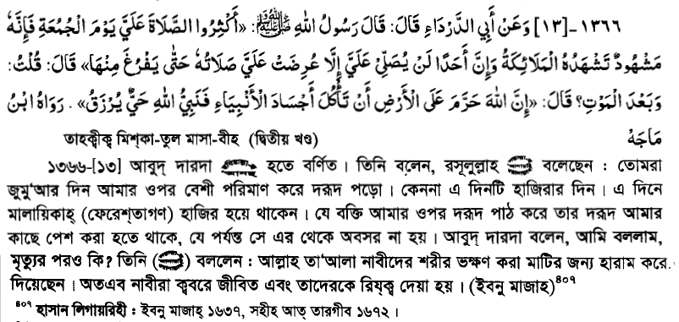

Vip: https://www.youtube.com/watch?v=orYNwrsumPs